Anh Nguyen

CS 3810

Define and Normalization

1. **Database Design**

The Database for the given case study is containing four tables such as Customer, Flight, Ticket and the Payment .These four tables are necessary for the developing a centralized database system for the given case study. Each table are defined as follows in brief with Data type, Keys and the attributes of the table.

1. **Customer**

The customer table in the database contains eight attributes which are defined as follows with help of a E-R diagram with appropriate keys. There in the E-R diagram the Primary keys are defined by the Underline data and the foreign key are defined by the italic data. Thus the customer table is defined as follows:

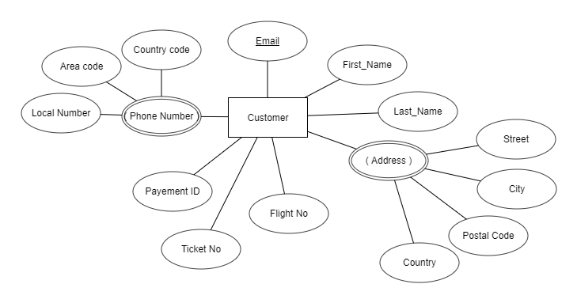 Figure: Customer Table ERD

Thus there are eight attributes in the customer table such as First_Name, Last_Name, Address, Phone Number, **Email*, Flight No, Ticket No, PaymentID*** where Email is the Primary key in the table and the Flight No, Ticket No and the PaymentID is the foreign keys of the customer table. There are two multivalve and composite attributes in the table such as Phone Number and Address.

1. **Flight**

**There are** seven attributes in the Flight table such as **Flight No**, Flight_Origin, Flight_Destination, Flight_Length, Departing_Time, Arrival_Time, and Price where Flight No is the **primary key** in the table. The E-r Diagram for the table is given as follows:

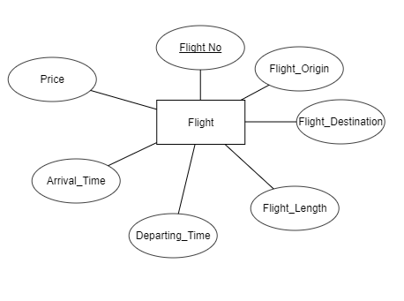

Figure: E-R diagram of Flight Table

The relational schema of the table is given as follows:

**Flight (Flight No, Flight_Origin, Flight_Destination, Flight_Length, Departing_Time, Arrival_Time, Price)**

There Flight No is the table is the primary key.

1. **Ticket**

**T**here are five attributes in the Ticket table such as **Ticket No**, ***Flight No***, Customer_Name, Date_Of_Booking and Departing_Time. There Ticket No is the **primary key** in the table and the Flight No is the **Foreign Key** in the given Ticket Table

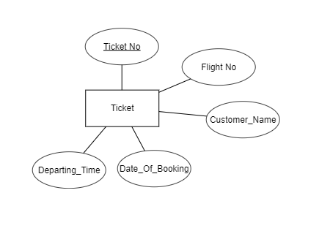

Figure: E- R diagram For Ticket Table

Relational Schema of the Ticket Table is given as follows:

**Ticket (Ticket No, *Flight No*, Customer_Name, Date_Of_Booking, Departing_Time)**

There are a primary key in the table that is Ticket No and the Flight No is the foreign key in the Ticket Table.

1. **Payment**

**There** are five attributes in the payment table such as **PaymentID**, Customer_Name, Email, Status, and ***Flight No.*** There PaymentID is the primary key in the table, and the Flight No is the foreign key in the table.

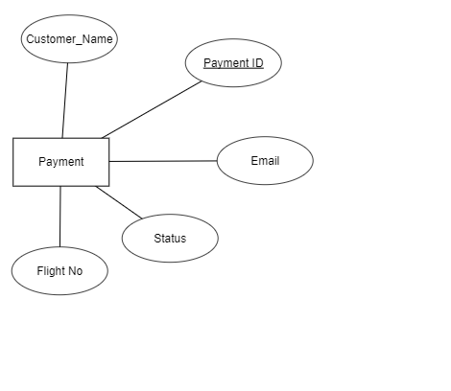

Figure: E-R Diagram for Payment Table

Relational schema for the Ticket Table is given as follows:

**Payment (Payment ID, *Flight No*, Customer_Name, Email, Status)**

There in the table the **Payment ID** is the **primary key** in the table and the **Flight No** is the **foreign key** in the table.

Thus these are the design tables in the centralized database for the given case study.

1. **Normalized Database Schema**

The normalized database schema does not contain any data duplicity or the redundant data. Thus the normalized schema of the database is given as follows:

* 1. **Customer**

The relation schema for the customer table is given as follows:

Customer ( **Email,** Name, Address(Street, City, Postal Code, Country), ***Flight No, Ticket No, PaymentID***, Phone Number (Local Number, Area Code, Country Code))

* 1. **Flight**

The Normalized schema for the Flight Table is given as follows:

Flight (**Flight No**, Flight_Origin, Flight_Destination, Flight_Length, Departing_Time, Arrival_Time, Price)

* 1. **Ticket**

**The** Normalized schema for the Ticket table is given as follows:

Ticket ( **Ticket No**, ***Flight No***, Customer_Name, Date_Of_Booking, Departing_Time)

* 1. **Payment**

The normalized schema for the Payment table is given as follows:

Payment (**Payment ID**, ***Flight No***, Customer_Name, Email, Status)